Advanced Algebra Name: ____________________

Chapter 7 Retest Period: ________

7.1 Evaluate nth root of real numbers Objective Met: Yes/No
7.2 Simplify rational expressions Objective Met: Yes/No
7.2 Simplify radical expressions Objective Met: Yes/No
7.2 Add and subtract roots and radicals Objective Met: Yes/No
7.3 Perform operations with functions Objective Met: Yes/No
7.3 Find and use composite functions Objective Met: Yes/No
7.4 Find inverses of linear functions Objective Met: Yes/No
7.4 Find inverses of nonlinear functions Objective Met: Yes/No
7.5 Graph square root and cube root functions Objective Met: Yes/No
  - Solve equations containing radicals and rational exponents Objective Met: Yes/No

In questions 1 – 4, rewrite the expression in radical or rational exponent form and then evaluate the expression.

1. 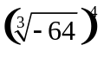 2. 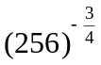

rational exponent form: _____ radical form: _____
answer: _____ answer: _____

In questions 3 – 6, simplify the expression.

3. 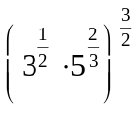 4. 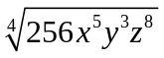

answer: ___________ answer: __________

5. 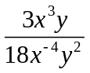 6. 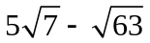

answer: __________ answer: __________

In questions 7 – 10, let f(x) = x² + 1 and g(x) = x - 2, perform the indicated operation and state the domain.
7. 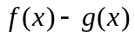 8. 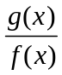

answer: ___________ answer: __________
domain: _________________________ domain: _________________________

9. 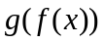 10. 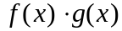

answer: __________ answer: __________
domain: _________________________ domain: _________________________

In question 11, choose the correct inverse.
11. 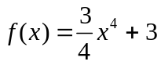 A. y = 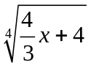
B. y = 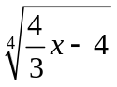
C. y = 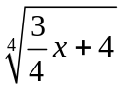
D. y = 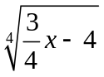

In question 12, verify if f and g are inverses.

12. f(x) = 2x – 6, g(x) = 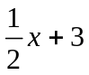

In questions 13 – 14, graph and then state if the inverse is a function.
13. 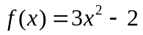 14. 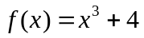
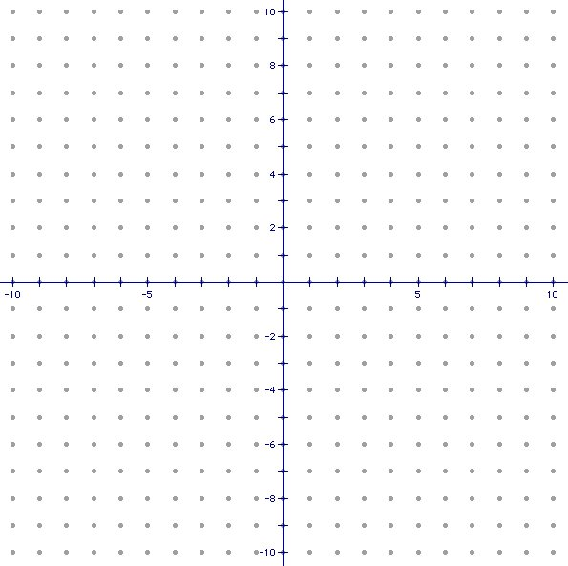

Inverse a function? _____ Inverse a function? _____

In questions 15 – 16, graph and state the domain and range.

15. 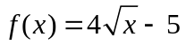 16. 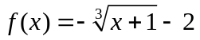

Domain: _________________________ Domain: _________________________
Range: __________________________ Range: __________________________

In questions 17 – 20, solve the equation. Check for extraneous solutions.

17. 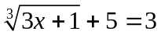 18. 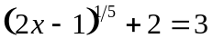

answer: __________ answer: ___________
19. 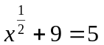 20. 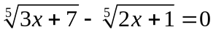

answer: __________ answer: ___________
In questions 21 – 22, find what is needed.

21. The volume of a cone can be found using the formula V = 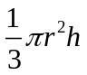 where r is the radius of the base, and h is the height. Find the length of the radius of a cone that has a volume of 46.9m³ and height of 12m. Round your radius to two decimal places.

radius = __________

22. The formula to convert Celsius, C, to Fahrenheit, F, is 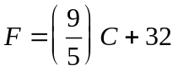. Write the inverse function. Use the inverse function to find the temperature in Celsius if it is 53° Fahrenheit. Round the temperature to two decimal places.

inverse: __________
Celsius = __________

